Name of Project: Putting light on the situation

Grade: 1

Big idea: CAUSE and EFFECT

DESIRED RESULTS
Established Goals (Standards, Performance Indicators, Learning Goals):

Science

1-PS4-4. Use tools and materials to design and build a device that uses light to solve a problem.

Engineering Design

ETS1-1. Ask questions, make observations, and gather information about a situation people want to change, to define a simple problem that can be solved through the development of a new or improved object or tool.

ETS1-2. Develop a simple sketch, drawing, or physical model to illustrate how the design of an object can solve a given problem.

ELA

RL.1.3 Describe characters, settings, and major events in a story, using key details.

L.1.5 Add drawings or other visual displays to descriptions when appropriate to clarify ideas, thoughts, and feelings.

Mathematics

1.MD.A.2 Express the length of an object as a whole number of length units, by laying multiple copies of a shorter object (the length unit) end to end; understand that the length measurement of an object is the number of same-size length units that span it with no gaps or overlaps.

Understandings:  A circuit is made up of interacting parts  The user needs to be considered when making design choices | Essential Question:  How can I design and build a wearable technology with a working circuit for a specific user?
Students will know:  - design thinking process: empathize, define need, ideate, prototype, test  -the different components of a circuit (battery, connector, LED) and how they behave  - energy flows from the positive terminal of the battery, through components of a circuit (such as lights) as current, and back to the negative terminal of the battery.  - understand that a switch interrupts the flow of electricity through a circuit | Students will be able to do:  - work through different stages of the design thinking process  - draw a sketch of their idea  - build a simple circuit using a battery, copper tape and LEDs  - create a switch in a circuit

EVIDENCE/ASSESSMENTS:
Performance Task:
Goal: Create a solution of being stuck in the dark when the electricity goes out
Role: Electrical designers
Audience: Community of Pioneer
Situation: When the power is cut and the lights go off in the middle of the night, people react differently- some people get afraid of being in the dark, some people feel lonely if they are not with others, some people feel nervous about walking around and falling and other people could feel irritable that they cannot carry on doing what they were doing. As Pioneer designers, how can we address the need of people being in the dark? What can we create that will allow people to not experience these emotions when the lights go off?

Product: Wearable product containing a circuit and LED
Standards of Criteria:
- A working circuit with a switch
- The light must be wearable
- The product must be unique and attractive to users

Design Process:

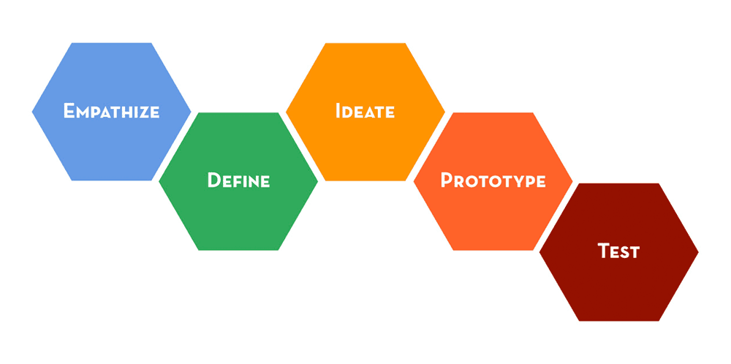
Evidence/Assessments:
- Rubric to assess product
- Design Journal to assess process
- Video to assess student thinking
- Interviews with students about the design thinking process
- Pre and post drawing about how circuits work

LEARNING PLAN
Learning Activities:

Session 1: Empathize and define the need (1 hour)

- Introduction about being stuck in the dark and being designers (10 minutes)
- Case study presentation- read the story of a participant (10 minutes)
- What feelings did you hear in the story? (10 minutes)
- Draw this person’s face showing the feelings they expressed (10 minutes)
e. Define the need (10 minutes)

Present performance task

include this madlib:

Design a way for ___(specific group of people)___ to better ___(situation)___ .

Exploring the feelings of being stuck in the dark
- Feeling lonely
- Feeling nervous
- Feeling afraid
- Feeling irritable

Collect design journals

Session 2: Play with circuits and ideate (1 hour)

- Introduce Materials (5 minutes)
- LED, Battery and Alligator clips (word wall)

b. Try light up an LED (10 minutes)
c. Explanation about how circuits work (10 minutes)

Some good questions to facilitate discussion:
- What are the different components in this system that you created?
- What are the behaviors of the different components? (Battery=power, conductor carries the electricity, LED produces Light)
- What is the goal of this system? (The goal is to allow the energy from the battery to flow to the LED and give it power so it can light up)
- How does the energy move through the system? (When a closed loop forms, the energy flows from the positive side of the battery through the conductive wires to reach the LED, flowing through the device to give it power. The current flows toward the opposite side of the power source; the negative side)
- How can you make a circuit stop working? (If there is any opening in the circuit the current will not be able to flow and the LED won’t light up).

Show diagram on wall with more words
- power source/battery
- negative terminal
- positive terminal
- connector
- current (flow of electrons)
- load/LED
- circuit

Show video explaining how electric circuits work
https://www.brainpop.com/science/energy/electriccircuits/

d. Play human circuit role play (10 minutes)

- Students need to arrange themselves to form a closed working circuit. The “current“ needs to show which way he/she is flowing from.
- 4 students per group
- Each student is giving a sticky note with each role:
- Battery with a + and - side
- Load/LED with a + and - side
- Current (flow of electrons)
- Connector
- Each team gets given a set of alligator clips

e. Ideate: (30 minutes)
What can we create for our user that will be helpful for them using a circuit?
- Brainstorm discussion (5 minutes)
- Explain instead of using alligator clips we’ll use copper tape.
- Post-its on a wall of different body parts we can make a wearable light source (10 minutes)
- Choose 2 ideas you like - must be different and draw in design journal (15 minutes)

Session 3: Prototype and create (1 hour)

- Creating a switch (10 minutes):

Watch the simulation: http://tinyurl.com/no2k3ls
b. Show examples of switches (10 minutes)
- Must show how the copper tape needs to have contact with the copper tape
- You can use sticky tape but not to cover where the electrons are flowing
- The switch must be easy for the user to move on and off
c. Prototype: (30 minutes)
- Students can use a number of different materials: felt, paper, pipe cleaners, sticky tape
- Students need to decide on the amount of paper/felt that they need

According to one chosen design, create a prototype.
Each pair gets:
- 20cm of copper tape
- Paper
- LED
- Battery

Session 4: Finish building, test and iterate (1 hour)

- Reflect (15minutes)
  - What problem did you have?
  - How did you fix it?

- Test (15 minutes)
- Pairs will assess other groups products

- Reflect on feedback. (10 minutes)
- What two things are you going to improve to make it better for your user?
- Write it in design journal.

c. Improve (20 minutes)

Session 5: Present (1hour)

- Practice presentation (10 minutes)
- Tell us about your product
- How did you come up with the idea?
- What was the biggest challenge?
- How did you improve your design?

b. Presentations (40 minutes)

c. Reflections (10 minutes)

Resources:

LED: https://learn.sparkfun.com/tutorials/light-emitting-diodes-leds?_ga=1.260027791.425021656.1446594242

TO DO:

Performance task
Rubric
Design journal
Create stories for each user
Design process poster
Poster of circuit with words
Sticky notes with circuit components
Interview questions

